Netflix Content Type Analysis
Distribution of Movies and TV Shows in the cleaned Netflix dataset (8,786 unique titles, added 2008 to 25 Sep 2021).

1. Total Movies and TV Shows
Content type | Titles | Share
Movies | 6,123 | 69.7%
TV Shows | 2,663 | 30.3%
Total | 8,786 | 100%

2. Content distribution
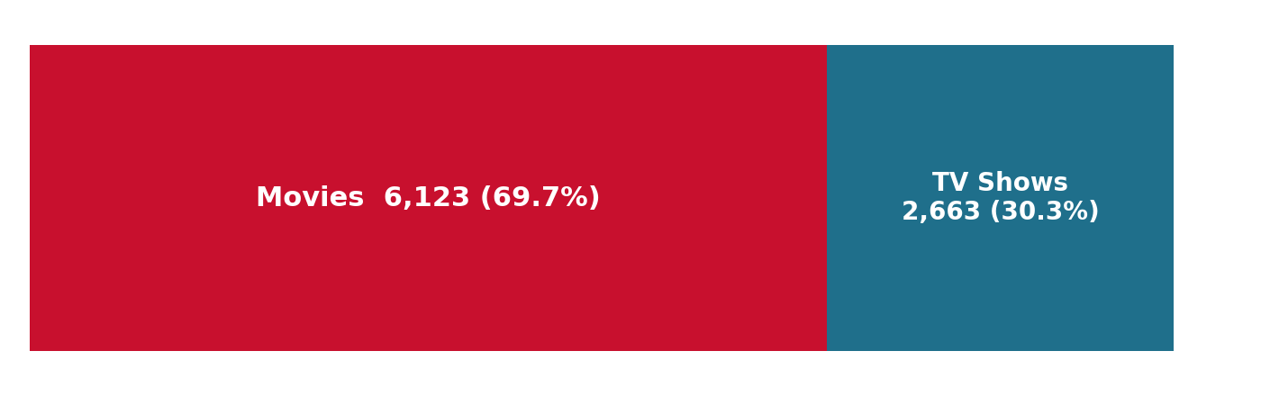
Movies outnumber TV Shows by about 2.3 to 1.
Titles added per year
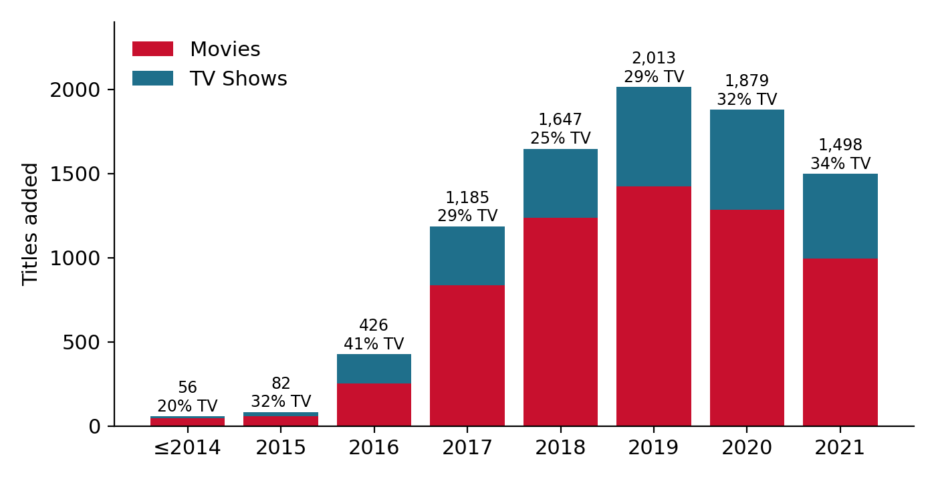

3. Comparing proportions
Audience mix: share of each content type by audience group.
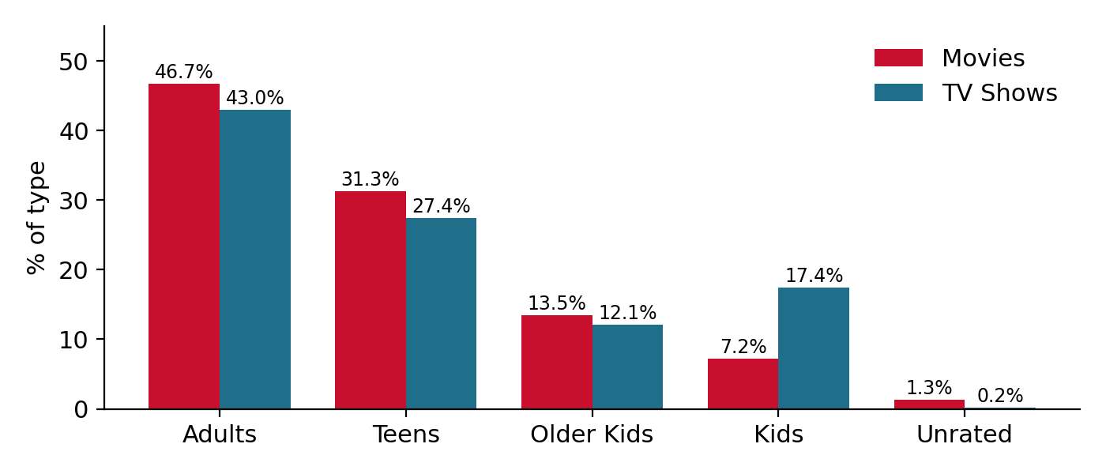
Top primary genres: Movies | Titles | Top primary genres: TV Shows | Titles
Dramas | 1,597 | International TV Shows | 772
Comedies | 1,209 | Crime TV Shows | 399
Action & Adventure | 859 | Kids’ TV | 385
Documentaries | 829 | British TV Shows | 252
Children & Family Movies | 605 | Docuseries | 220

4. Key findings
- Movies dominate. There are 6,123 movies (69.7%) against 2,663 TV shows (30.3%), roughly 2.3 movies for every TV show.
- Additions peaked in 2019. 2,013 titles were added that year. TV Shows made up between 25% and 34% of additions in every year from 2017 on.
- Newer releases lean towards TV. TV Shows were 25% of titles released in 2014, 46% in 2020 and 53% in 2021 (a partial year, as the data ends 25 Sep 2021).
- Both types skew adult. Adults are 47% of movies and 43% of TV shows, but TV has more than twice the share aimed at Kids (17.4% vs 7.2%).
- Different genre profiles. Dramas and Comedies lead movies, while International TV Shows and Crime TV Shows lead TV.
- Caveat. These are counts of titles, not viewing hours. A single TV show can represent many hours of content.

